Project Design Phase-II
Technology Stack (Architecture & Stack)
Date | 7 march S2025
Team ID
Project Name | Visualization Tool for Electric  Vehicle Charge and Range Analysis
Maximum Marks | 4 Marks

Technical Architecture:
The Deliverable shall include the architectural diagram as below and the information as per the Table-1 & Table-2
Example: EV Charge Data Collection & Visualization Platform

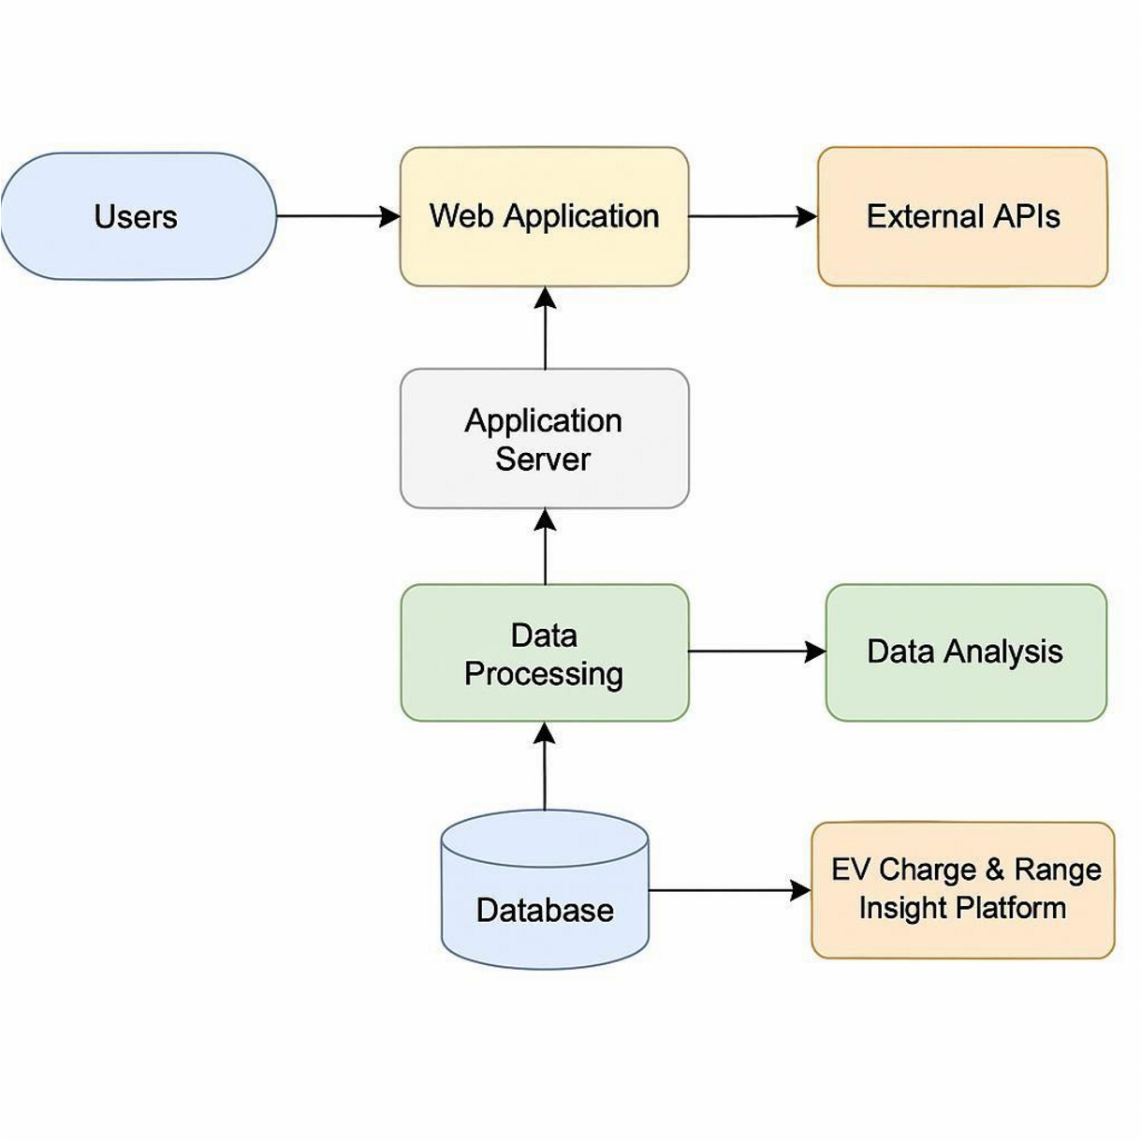
Table-1 : Components & Technologies:
S.No | Component | Description | Technology
1 | User Interface | User dashboard for EV data insights via browser or mobile | React.js,  TailwindCSS,  HTML5
2 | Application Logic-1 | EV charge & range data processing | Python, FastAPI
3 | Application Logic-2 | User behavior analytics | Python ML libraries  (scikit-learn, pandas)
4 | Application Logic-3 | Geolocation-based recommendations | Google Maps API, OpenRouteService
5 | Database | Storing user profiles, session logs, raw EV data | PostgreSQL
6 | Cloud Database | Cloud-hosted scalable data storage | AWS RDS, Amazon DynamoDB
7 | File Storage | Storing data exports, visualizations | AWS S3, local FS
8 | External API-1 | Fetch real-time EV station data | NREL API, Open  Charge Map API
9 | External API-2 | Weather or temperaturedependent range prediction | OpenWeatherMap  API
10 | Machine Learning Model | Forecast range and suggest efficiency improvements | Regression + Time Series Models
11 | Infrastructure  (Server / Cloud) | Deploying services | AWS EC2, Lambda, Kubernetes
Table-2 : Application Characteristics:
S.No | Characteristics | Description | Technology
1 | Open-Source Frameworks | Frontend and backend using opensource tools | React.js, FastAPI, PostgreSQL
2 | Security  Implementations | Authentication, encryption, access control | JWT, OAuth 2.0,  HTTPS, IAM Roles
3 | Scalable  Architecture | Microservices & cloud containers | Docker, Kubernetes, REST APIs
4 | Availability | Highly available multi-zone cloud setup | AWS Load Balancer, Multi-AZ RDS
5 | Performance | Optimized charts, caching, async jobs | Redis, CloudFront CDN, Async APIs
References:
https://c4model.com/ https://www.ibm.com/cloud/architecture https://aws.amazon.com/architecture https://medium.com/the-internalstartup/how-to-draw-useful-technicalarchitecture-diagrams2d20c9fda90d https://openchargemap.org/site/develop/api https://openweathermap.org/api
https://developer.nrel.gov/docs/transportation/alt-fuel-stations-v1/

